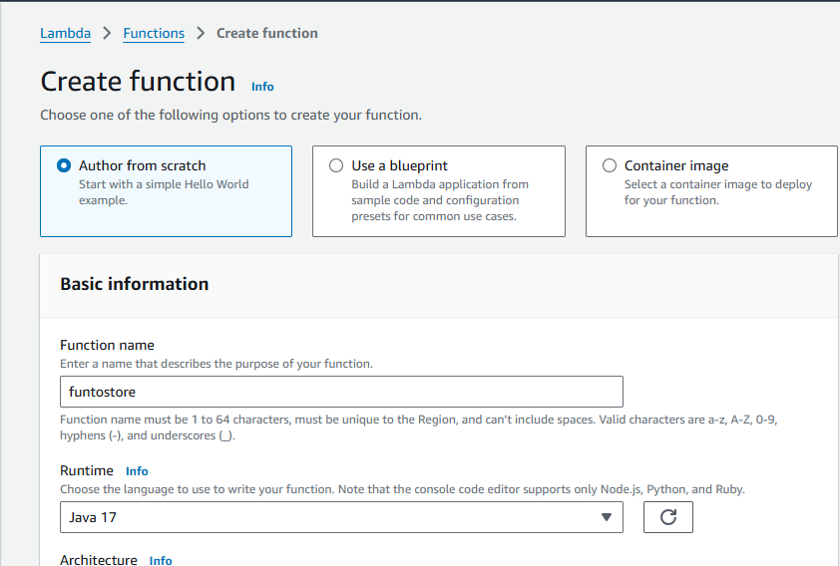

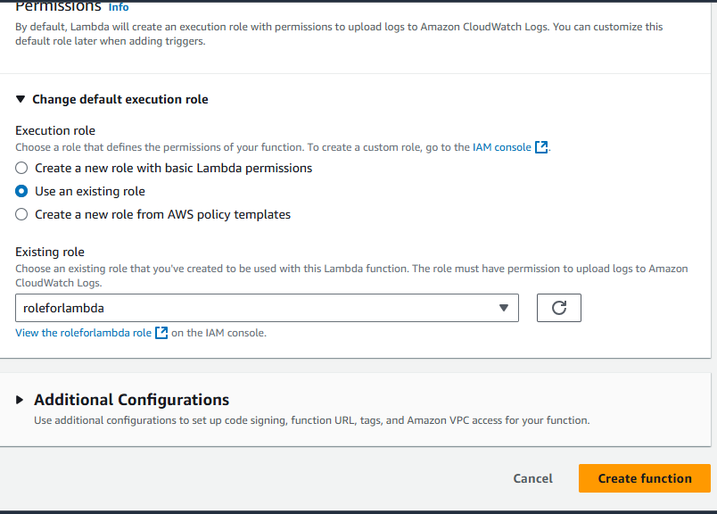

GIve permission for lambda to access s3 and dynamoDB

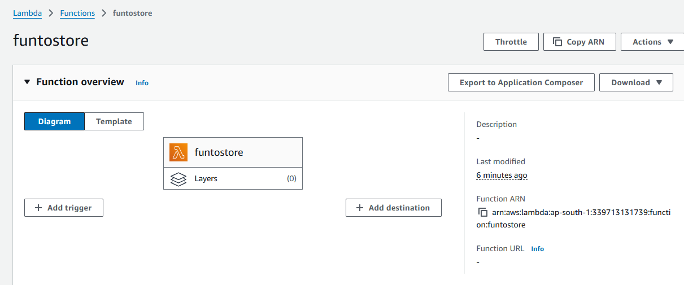

Now code and deploy

**Python code to run in lambda to store csv in dynamodb table**

import boto3

import csv

import os

import logging

# Initialize clients for S3 and DynamoDB

s3_client = boto3.client('s3')

dynamodb_client = boto3.resource('dynamodb')

table_name = os.getenv('TABLE_NAME') # Get DynamoDB table name from environment variable

bucket_name = os.getenv('BUCKET_NAME') # Get S3 bucket name from environment variable

table = dynamodb_client.Table(table_name)

# Set up logging

logger = logging.getLogger()

logger.setLevel(logging.INFO)

def lambda_handler(event, context):

# Specify the CSV file key (update this with the actual path to your CSV file)

csv_file_key = 'data/myfile.csv' # Change to the actual CSV file path

try:

# Get the CSV file from S3

csv_content = s3_client.get_object(Bucket=bucket_name, Key=csv_file_key)['Body'].read().decode('utf-8')

# Parse CSV content

csv_reader = csv.DictReader(csv_content.splitlines())

# Insert each row into DynamoDB

with table.batch_writer() as batch:

for row in csv_reader:

batch.put_item(Item=row)

logger.info(f"CSV file '{csv_file_key}' from bucket '{bucket_name}' has been processed and stored in DynamoDB.")

except Exception as e:

logger.error(f"Error processing file {csv_file_key} from bucket {bucket_name}: {e}")

return {

'statusCode': 500,

'body': f"Error processing the file '{csv_file_key}'."

}

return {

'statusCode': 200,

'body': f"Processed CSV file '{csv_file_key}' and stored in DynamoDB table '{table_name}'."

}

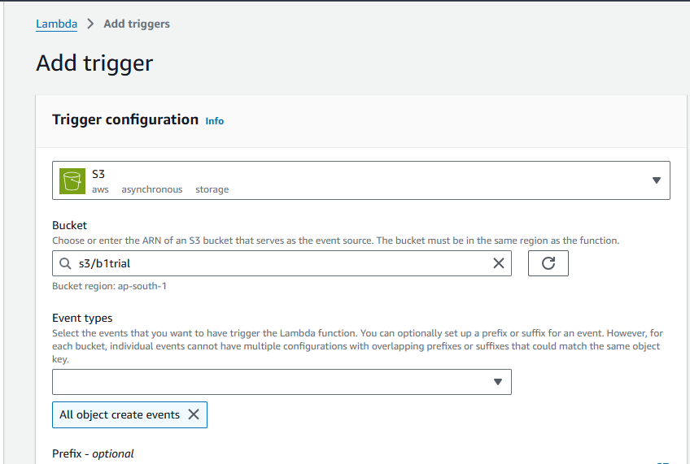

Add trigger to to run lambda